**Linkage Analysis Project**

**2022 Fall**

**B08502006**

**Shiu-Cheng, Wang**

**王旭承**

**Linkage analysis project**

**Formulation of problem**

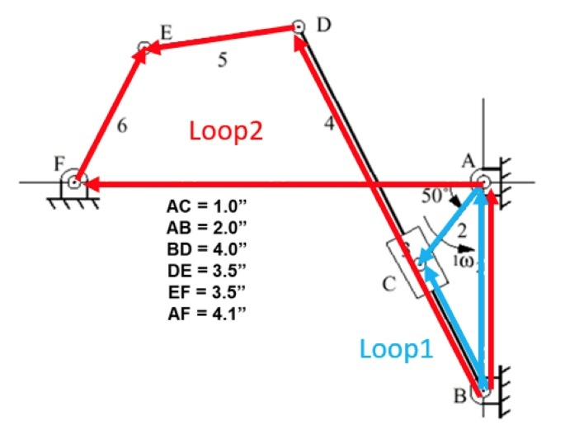

Figure 1

First define:

The respective from 1 to 8 is defined as the angle from the positive x-axis, with counter-clockwise being the positive direction.

Given the inputs, the constants are r1, r2, r3, r4, r5, r6, r7, r8, , , . The unknowns are r3, , , , , .

1. Position equations

(a) Loop 1:

x-direction:

y-direction:

Plug in the condition that

x-direction:

y-direction:

(b) Loop 2:

x-direction:

y-direction:

Plug in the conditions that

x-direction:

y-direction:

First solve Loop 1 to yield r3, , then solve for

2. Velocity equations

By differentiating the position equations used above:

(a) Loop 1:

x-direction:

y-direction:

(b) Loop 2:

x-direction:

y-direction:

3. Acceleration equations

(a) Loop 1:

x-direction:

y-direction:

(b) Loop 2:

x-direction:

y-direction:

**Computer program**

1. Parameters:

*#the symbols needed later, theta is represented as t, delxx is the calibrating value of the unknowns (xx) we want to estimate*

*#v stands for velocity, w stands for angular velocity (rad/s), a is the angular acceleration, except for ar3 being the acceleration of vector r3*

r3, t3, t5, t6, delr3, delt3, delt5, delt6, v3, w3, w5, w6, ar3, at3, a5, a6, t, x, y= sym.symbols('r3, t3, t5, t6, delr3, delt3, delt5, delt6, v3, w3, w5, w6, ar3, at3, a5, a6, t, x, y')

*# It is important to distinguish between the symbols and values in a symbolic calculation. The line above are the symbols, which are the unknows we aim to solve or we solved in the way;*

*# the line below is the ones being numeric.*

rv2, rv1, rv4, rv5, rv6, rv7, wv2, av2 = [float(i) for i in input("Enter parameters, in the sequence of r2, r1, r4, r5, r6, r7, w2, a2: ").split()] *#Input of the given parameters*

which = int(input("enter 1 if you want the position relation plot; enter 2 if you want velocity relation plot; else if you want acceleration plot: "))

rv8 = rv1

2. Numerical method:

(a) Initial values

*#find the desired initial values for t5 and t6*

phi = sym.atan(rv2/rv1)

xright = rv4*sym.sin(phi)

yright = rv4*sym.cos(phi) - rv1

xleft = -rv7

yleft = 0

b = ((xright - xleft)**2 + yright**2)**0.5

eq1 = sym.Eq((x+b)**2 + y**2 - rv6**2,0)

eq2 = sym.Eq(x**2 + y**2 - rv5**2,0)

result = sym.solve([eq1,eq2],(x,y))

for i in result:

    if i[0].is_real and i[1].is_real:

        x = i[0]

        y = abs(i[1])

tp1 = sym.atan(y/x)

*#There are two circumstances. If the first method won’t work, the second will*

try:

    if x*y <0:

        tp1 = sym.N(tp1+sym.pi)

        tp2 = sym.atan(y/(x+b))

    if y/(x+b) <0:

        tp2 = sym.N(tp2+sym.pi)

    theta = sym.atan(yright/(xright-xleft))

    tp1 += theta

    tp2 += theta

    tp2 += sym.N(sym.pi)

except:

    t3min56 = sym.N(sym.pi - sym.atan(rv1 / rv7) - sym.acos((rv1**2 + rv7**2 + rv4**2 - (rv5 + rv6)**2) / (2 * sym.sqrt(rv1**2 + rv7**2) * rv4)))

    xright = rv4 * sym.cos(t3min56)

    yright = rv4 * sym.sin(t3min56) - rv1

    tp1 = sym.atan(yright/(xright + rv7))

    tp1 = sym.N(sym.pi + tp1)

    tp2 = tp1 + 0.01

*#The initial guesses of the positions in Loop one are all ones.*

rv3 = rv1

tv3 = 1.0

tv5 = tp1

tv6 = tp2

(b) Iterations

The rationale of using symbolic calculation is that can be seen as functions of the estimates. Each time we plug in new values of , we get a new set of values of . Repeat this calculation until f1 and f2 is close enough to zero.

*#take 35 values of input angles with an equal interval of 10 degree for the for loop*

for i in range(1,37):

    tv2 = 10*i/180*sym.pi

    print("tv2 =", 10*i)

    eqt = sym.Eq(0.5 * av2 * t**2 + wv2 * t - sym.N(10/180*sym.pi),0)

    resultt = sym.solve(eqt,t)

    tv = max(resultt)

    wv2 = wv2 + av2 * tv

*#Loop1*

*#x-direction, we want to find solutions for f1 == 0*

    f1 = rv2 * sym.cos(tv2) - r3 * sym.cos(t3) *# eq1*

*#y-direction*

    f2 = rv1 + rv2 * sym.sin(tv2) - r3 * sym.sin(t3) *#eq2*

    eq1 = sym.Eq(sym.diff(f1, r3) * delr3 + sym.diff(f1, t3) * delt3, -f1)

    eq2 = sym.Eq(sym.diff(f2, r3) * delr3 + sym.diff(f2, t3) * delt3, -f2)

    result1 = sym.solve([eq1, eq2], (delr3, delt3)) *# the result contain the symbolic representation of delr3 and delt3*

    delr3v = 0 *#in each input angle, delta is set to 0*

    delt3v = 0

*#we calculate the delr3v and delt3v and add them to r3v and t3v.Everytime we adjust the value of r3 and t3, we plug them into eq1 and eq2 to find if f1 and f2 are both lesser than or equal to 0.0001*

    while abs(sym.N(f1.subs({t3: tv3, r3: rv3}))) > 0.0001 or abs(sym.N(f2.subs({t3: tv3, r3: rv3}))) > 0.0001:

        delr3v = sym.N(result1[delr3].subs({t3:tv3, r3: rv3}))

        delt3v = sym.N(result1[delt3].subs({t3:tv3, r3: rv3}))

        rv3 += delr3v

        tv3 += delt3v

*#if the resulted values of r3 or t3 are not in the limits, it cannot occur.*

    if round(tv3, 4) > round(maxt3,4) or round(tv3,4) < round(mint3,4): *#the round() is used to avoid the wrong result from the calculation above*

        print(**f**"This input angle {10*i} degree cannot occur!")

        table.append([10*i,"N","N","N","N","N","N","N","N","N"])

        continue

    else:

        t2plot6[i-1] = np.float64(10*i)

        t3plot[i-1] = np.float64(tv3/sym.N(sym.pi)*180)

        r3plot[i-1] = np.float64(rv3*100)

        table.append([10*i])

*#Loop 2, basically the same as above*

    f3 = rv4 * sym.cos(tv3) + rv5 * sym.cos(t5) + rv6 * sym.cos(t6) + rv7

    f4 = rv4 * sym.sin(tv3) + rv5 * sym.sin(t5) + rv6 * sym.sin(t6) - rv8

    eq3 = sym.Eq(sym.diff(f3, t5) * delt5 + sym.diff(f3, t6) * delt6, -f3)

    eq4 = sym.Eq(sym.diff(f4, t5) * delt5 + sym.diff(f4, t6) * delt6, -f4)

    result2 = sym.solve([eq3, eq4], (delt5, delt6))

    delt5v = 0

    delt6v = 0

    while abs(sym.N(f3.subs({t5: tv5, t6: tv6}))) > 0.0001 or abs(sym.N(f4.subs({t5: tv5, t6: tv6}))) > 0.0001:

        delt5v = sym.N(result2[delt5].subs({t5:tv5, t6: tv6}))

        delt6v = sym.N(result2[delt6].subs({t5:tv5, t6: tv6}))

        tv5 += delt5v

        tv6 += delt6v

*#let the angles yielded always be in 0 to 2*pi*

        while tv5 < 0:

            tv5 += sym.N(2 * sym.pi)

        while tv6 < 0:

            tv6 += sym.N(2 * sym.pi)

        while tv5 > 2 * sym.pi:

            tv5 -= sym.N(2 * sym.pi)

        while tv6 > 2 * sym.pi:

            tv6 -= sym.N(2 * sym.pi)

    t5plot[i-1] = np.float64(tv5/sym.N(sym.pi)*180)

    t6plot[i-1] = np.float64(tv6/sym.N(sym.pi)*180)

3. The complete code:

*#This program uses symbolic calculation, while the iterative numerical methods to find the solution of non-linear equations are used.*

import sympy as sym

import matplotlib.pyplot as plt

import numpy as np

from tabulate import tabulate

*#the symbols needed later, theta is represented as t, delxx is the calibrating value of the unknowns (xx) we want to estimate*

*#v stands for velocity, w stands for angular velocity (rad/s), a is the angular acceleration, except for ar3 being the acceleration of vector r3*

r3, t3, t5, t6, delr3, delt3, delt5, delt6, v3, w3, w5, w6, ar3, at3, a5, a6, t, x, y= sym.symbols('r3, t3, t5, t6, delr3, delt3, delt5, delt6, v3, w3, w5, w6, ar3, at3, a5, a6, t, x, y')

*# It is important to distinguish between the symbols and values in a symbolic calculation. The line above are the symbols, which are the unknows we aim to solve or we solved in the way;*

*# the line below is the ones being numeric.*

rv2, rv1, rv4, rv5, rv6, rv7, wv2, av2 = [float(i) for i in input("Enter parameters, in the sequence of r2, r1, r4, r5, r6, r7, w2, a2: ").split()] *#Input of the given parameters*

which = int(input("enter 1 if you want the angle position relation plot; enter 2 if you want the position of point D & E; enter 3 if you want velocity relation plot; else if you want acceleration plot: "))

rv8 = rv1

*# a = np.full( (10,1),0.00001)*

t2plot6 = np.full((36,1),0.00001)

t3plot = np.full((36,1),0.00001)

r3plot = np.full((36,1),0.00001)

t5plot = np.full((36,1),0.00001)

t6plot = np.full((36,1),0.00001)

dxplot = np.full((36,1),0.00001)

dyplot = np.full((36,1),0.00001)

explot = np.full((36,1),0.00001)

eyplot = np.full((36,1),0.00001)

evxplot = np.full((36,1),0.00001)

evyplot = np.full((36,1),0.00001)

eaxplot = np.full((36,1),0.00001)

eayplot = np.full((36,1),0.00001)

table = list()

*#find the desired initial values for t5 and t6*

phi = sym.atan(rv2/rv1)

xright = rv4*sym.sin(phi)

yright = rv4*sym.cos(phi) - rv1

xleft = -rv7

yleft = 0

b = ((xright - xleft)**2 + yright**2)**0.5

eq1 = sym.Eq((x+b)**2 + y**2 - rv6**2,0)

eq2 = sym.Eq(x**2 + y**2 - rv5**2,0)

result = sym.solve([eq1,eq2],(x,y))

for i in result:

    if i[0].is_real and i[1].is_real:

        x = i[0]

        y = abs(i[1])

tp1 = sym.atan(y/x)

*#There are two circumstances.  If the first method won’t work, the second will*

try:

    if x*y <0:

        tp1 = sym.N(tp1+sym.pi)

        tp2 = sym.atan(y/(x+b))

    if y/(x+b) <0:

        tp2 = sym.N(tp2+sym.pi)

    theta = sym.atan(yright/(xright-xleft))

    tp1 += theta

    tp2 += theta

    tp2 += sym.N(sym.pi)

except:

    t3min56 = sym.N(sym.pi - sym.atan(rv1 / rv7) - sym.acos((rv1**2 + rv7**2 + rv4**2 - (rv5 + rv6)**2) / (2 * sym.sqrt(rv1**2 + rv7**2) * rv4)))

    xright = rv4 * sym.cos(t3min56)

    yright = rv4 * sym.sin(t3min56) - rv1

    tp1 = sym.atan(yright/(xright + rv7))

    tp1 = sym.N(sym.pi + tp1)

    tp2 = tp1 + 0.1

*#The initial guesses of the positions in Loop one are all ones.*

rv3 = 1.0

tv3 = 1.0

tv5 = tp1

tv6 = tp2

*#Whether the input link r2 can revolute 360 degree is dependent on maximum and minimum angle of r3*

*#The maximum and minimum angles have two restricts: one by Loop1 and one by Loop2*

*#t3max123 is the maximum angle allowed by Loop 1, same for t3min123*

t3max123 = sym.N(sym.pi / 2 + sym.asin(rv2 / rv1))

t3min123 = sym.N(sym.pi / 2 - sym.asin(rv2 / rv1))

*#t3max56 is the maximum angle allowed by Loop 2, same for t3min56*

if rv5 == rv6:

    t3max56 = sym.N(sym.pi - sym.atan(rv1 / rv7))

else:

    t3max56 = sym.N(sym.pi - sym.atan(rv1 / rv7) - sym.acos((rv1**2 + rv7**2 + rv4**2 - (rv5 - rv6)**2) / (2 * sym.sqrt(rv1**2 + rv7**2) * rv4)))

t3min56 = sym.N(sym.pi - sym.atan(rv1 / rv7) - sym.acos((rv1**2 + rv7**2 + rv4**2 - (rv5 + rv6)**2) / (2 * sym.sqrt(rv1**2 + rv7**2) * rv4)))

*# this yields the possible moving range of r3*

*#Because of the numbers in sympy are all complex, the complex ones should be excluded*

if t3max56.is_real:

    maxt3 = min(t3max123, t3max56)

else:

    maxt3 = t3max123

if t3min56.is_real:

    mint3 = max(t3min123, t3min56)

else:

    mint3 = t3min123

*# print("maxt3:", maxt3, "mint3:", mint3)*

*#Note that if and only if maxt3 == t3max123 and mint3 ==t3min123, r3 can revolute 360 degree!*

*#take 35 values of input angles with an equal interval of 10 degree for the for loop*

for i in range(1,37):

    tv2 = 10*i/180*sym.pi

    print("tv2 =", 10*i)

*#     t2plot[i-1] = np.float64(10*i)*

    eqt = sym.Eq(0.5 * av2 * t**2 + wv2 * t - sym.N(10/180*sym.pi),0)

    resultt = sym.solve(eqt,t)

    tv = max(resultt)

    wv2 = wv2 + av2 * tv

*# print("f")*

*#Loop1*

*#x-direction, we want to find solutions for f1 == 0*

    f1 = rv2 * sym.cos(tv2) - r3 * sym.cos(t3) *# eq1*

*#y-direction*

    f2 = rv1 + rv2 * sym.sin(tv2) - r3 * sym.sin(t3) *#eq2*

    eq1 = sym.Eq(sym.diff(f1, r3) * delr3 + sym.diff(f1, t3) * delt3, -f1)

    eq2 = sym.Eq(sym.diff(f2, r3) * delr3 + sym.diff(f2, t3) * delt3, -f2)

    result1 = sym.solve([eq1, eq2], (delr3, delt3)) *# the result contain the symbolic representation of delr3 and delt3*

    delr3v = 0

    delt3v = 0

*# print("s")*

*#everytime we adjust the value of r3 and t3, we plug them into eq1 and eq2 to find if f1 and f2 are both lesser than or equal to 0.0001*

    while abs(sym.N(f1.subs({t3: tv3, r3: rv3}))) > 0.0001 or abs(sym.N(f2.subs({t3: tv3, r3: rv3}))) > 0.0001:

        delr3v = sym.N(result1[delr3].subs({t3:tv3, r3: rv3}))

        delt3v = sym.N(result1[delt3].subs({t3:tv3, r3: rv3}))

        rv3 += delr3v

        tv3 += delt3v

*#if the resulted values of r3 or t3 are not in the limits, it cannot occur.*

    if round(tv3, 4) > round(maxt3,4) or round(tv3,4) < round(mint3,4): *#the round() is used to avoid the wrong result from the calculation above*

        print(**f**"This input angle {10*i} degree cannot occur!")

        table.append([10*i,"N","N","N","N","N","N","N","N","N"])

        continue

    else:

        t2plot6[i-1] = np.float64(10*i)

        t3plot[i-1] = np.float64(tv3/sym.N(sym.pi)*180)

        r3plot[i-1] = np.float64(rv3*100)

        table.append([10*i])

*#         print("rv3", rv3,"tv3:", tv3)*

*#Loop 2, basicallly the same as above*

    f3 = rv4 * sym.cos(tv3) + rv5 * sym.cos(t5) + rv6 * sym.cos(t6) + rv7

    f4 = rv4 * sym.sin(tv3) + rv5 * sym.sin(t5) + rv6 * sym.sin(t6) - rv8

    eq3 = sym.Eq(sym.diff(f3, t5) * delt5 + sym.diff(f3, t6) * delt6, -f3)

    eq4 = sym.Eq(sym.diff(f4, t5) * delt5 + sym.diff(f4, t6) * delt6, -f4)

    result2 = sym.solve([eq3, eq4], (delt5, delt6))

    delt5v = 0

    delt6v = 0

    while abs(sym.N(f3.subs({t5: tv5, t6: tv6}))) > 0.0001 or abs(sym.N(f4.subs({t5: tv5, t6: tv6}))) > 0.0001:

        delt5v = sym.N(result2[delt5].subs({t5:tv5, t6: tv6}))

        delt6v = sym.N(result2[delt6].subs({t5:tv5, t6: tv6}))

        tv5 += delt5v

        tv6 += delt6v

*#let the angles yielded always be in 0 to 2*pi*

        while tv5 < 0:

            tv5 += sym.N(2 * sym.pi)

        while tv6 < 0:

            tv6 += sym.N(2 * sym.pi)

        while tv5 > 2 * sym.pi:

            tv5 -= sym.N(2 * sym.pi)

        while tv6 > 2 * sym.pi:

            tv6 -= sym.N(2 * sym.pi)

    t5plot[i-1] = np.float64(tv5/sym.N(sym.pi)*180)

    t6plot[i-1] = np.float64(tv6/sym.N(sym.pi)*180)

*# print("tv5 = ", tv5, "tv6 = ", tv6)*

*#     print("tv5:",tv5,"tv6:", tv6)*

*#     print(f"position D:({sym.N(rv4*sym.cos(tv3))},{sym.N(rv4*sym.sin(tv3)-rv1)})", f"position E:({sym.N(rv4*sym.cos(tv3)+rv5*sym.cos(tv5))},{sym.N(rv4*sym.sin(tv3)+rv5*sym.sin(tv5)-rv1)})")*

    dx = round(sym.N(rv4*sym.cos(tv3)),4)

    dy = round(sym.N(rv4*sym.sin(tv3)-rv1), 4)

    ex = round(sym.N(rv4*sym.cos(tv3)+rv5*sym.cos(tv5)), 4)

    ey = round(sym.N(rv4*sym.sin(tv3)+rv5*sym.sin(tv5)-rv1), 4)

    dxplot[i-1] = np.float64(dx)

    dyplot[i-1] = np.float64(dy)

    explot[i-1] = np.float64(ex)

    eyplot[i-1] = np.float64(ey)

    table[i-1].extend((dx, dy, ex, ey))

*#velocity*

    eq1v = sym.Eq(sym.N(-rv2 * sym.sin(tv2) * wv2) - v3 * sym.cos(tv3) + rv3 * sym.sin(tv3) * w3, 0)

    eq2v = sym.Eq(sym.N(rv2 * sym.cos(tv2) * wv2) - v3 * sym.sin(tv3) - rv3 * sym.cos(tv3) * w3, 0)

    resultv1 = sym.solve([eq1v,eq2v],(v3,w3))

    wv3 = resultv1[w3]

    vv3 = resultv1[v3]

    eq3v = sym.Eq(-rv4 * sym.sin(tv3) * wv3 - rv5 * sym.sin(tv5) * w5 - sym.N(rv6 * sym.sin(tv6)) * w6, 0)

    eq4v = sym.Eq(rv4 * sym.cos(tv3) * wv3 + rv5 * sym.cos(tv5) * w5 + rv6 * sym.N(sym.cos(tv6)) * w6, 0)

    resultv2 = sym.solve([eq3v,eq4v],(w5,w6))

    wv5 = resultv2[w5]

    wv6 = resultv2[w6]

*#     print(f"Ve:({-rv4 * sym.sin(tv3) * wv3 - rv5 * sym.sin(tv5) * wv5},{rv4 * sym.cos(tv3) * wv3 + rv5 * sym.cos(tv5) * wv5})")*

    table[i-1].extend((round(-rv4 * sym.sin(tv3) * wv3 - rv5 * sym.sin(tv5) * wv5,4), round(rv4 * sym.cos(tv3) * wv3 + rv5 * sym.cos(tv5) * wv5,4)))

    if -rv4 * sym.sin(tv3) * wv3 - rv5 * sym.sin(tv5) * wv5 == 0:

        evxadd = 0.00001

        evxplot[i-1] = np.float64(evxadd)

    else:

        evxplot[i-1] = np.float64(round(-rv4 * sym.sin(tv3) * wv3 - rv5 * sym.sin(tv5) * wv5,4))

    if rv4 * sym.cos(tv3) * wv3 + rv5 * sym.cos(tv5) * wv5 == 0:

        evyadd = 0.00001

        evyplot[i-1] = np.float64(evyadd)

    else:

        evyplot[i-1] = np.float64(round(rv4 * sym.cos(tv3) * wv3 + rv5 * sym.cos(tv5) * wv5,4))

*#acceleration*

    eq1a = sym.Eq(-rv2 * sym.N(sym.cos(tv2)) * wv2 ** 2 - rv2 * sym.N(sym.sin(tv2)) * av2 - ar3 * sym.cos(tv3) + 2 * (vv3 * sym.N(sym.sin(tv3)) * wv3) + rv3 * sym.N(sym.cos(tv3)) * wv3 ** 2 + rv3 * sym.sin(tv3) * at3, 0)

    eq2a = sym.Eq(-rv2 * sym.N(sym.sin(tv2)) * wv2 ** 2 + rv2 * sym.N(sym.cos(tv2)) * av2 - ar3 * sym.sin(tv3) - 2 * (vv3 * sym.N(sym.cos(tv3)) * wv3) + rv3 * sym.N(sym.sin(tv3)) * wv3 ** 2 - rv3 * sym.cos(tv3) * at3, 0)

    resulta1 = sym.solve([eq1a,eq2a],(ar3,at3))

    atv3 = resulta1[at3]

    arv3 = resulta1[ar3]

    eq3a = sym.Eq(-rv4 * sym.cos(tv3) * wv3 ** 2 - rv4 * sym.sin(tv3) * atv3 - rv5 * sym.cos(tv5) * wv5 ** 2 - rv5 * sym.sin(tv5) * a5 - rv6 * sym.cos(tv6) * wv6 ** 2 - rv6 * sym.sin(tv6) * a6, 0)

    eq4a = sym.Eq(-rv4 * sym.sin(tv3) * wv3 ** 2 + rv4 * sym.cos(tv3) * atv3 - rv5 * sym.sin(tv5) * wv5 ** 2 - rv5 * sym.cos(tv5) * a5 - rv6 * sym.sin(tv6) * wv6 ** 2 + rv6 * sym.cos(tv6) * a6, 0)

    resultav2 = sym.solve([eq3a,eq4a],(a5,a6))

    av5 = resultav2[a5]

    av6 = resultav2[a6]

*#     print(f"Ae:({-rv4 * sym.cos(tv3) * wv3 ** 2 - rv4 * sym.sin(tv3) * atv3 - rv5 * sym.cos(tv5) * wv5 ** 2 - rv5 * sym.sin(tv5) * av5},{-rv4 * sym.sin(tv3) * wv3 ** 2 + rv4 * sym.cos(tv3) * atv3 - rv5 * sym.sin(tv5) * wv5 ** 2 - rv5 * sym.cos(tv5) * av5})")*

    table[i-1].extend((round(-rv4 * sym.cos(tv3) * wv3 ** 2 - rv4 * sym.sin(tv3) * atv3 - rv5 * sym.cos(tv5) * wv5 ** 2 - rv5 * sym.sin(tv5) * av5,4),round( -rv4 * sym.sin(tv3) * wv3 ** 2 + rv4 * sym.cos(tv3) * atv3 - rv5 * sym.sin(tv5) * wv5 ** 2 - rv5 * sym.cos(tv5) * av5, 4)))

    table[i-1].append(round(wv6, 4))

    eaxplot[i-1] = np.float64(round(-rv4 * sym.cos(tv3) * wv3 ** 2 - rv4 * sym.sin(tv3) * atv3 - rv5 * sym.cos(tv5) * wv5 ** 2 - rv5 * sym.sin(tv5) * av5,4))

    eayplot[i-1] = np.float64(round( -rv4 * sym.sin(tv3) * wv3 ** 2 + rv4 * sym.cos(tv3) * atv3 - rv5 * sym.sin(tv5) * wv5 ** 2 - rv5 * sym.cos(tv5) * av5, 4))

*# print("seven")*

t2plot6 = t2plot6[t2plot6 != 0.00001]

t3plot = t3plot[t3plot != 0.00001]

r3plot = r3plot[r3plot != 0.00001]

t5plot = t5plot[t5plot != 0.00001]

t6plot = t6plot[t6plot != 0.00001]

dxplot = dxplot[dxplot != 0.00001]

dyplot = dyplot[dyplot != 0.00001]

explot = explot[explot != 0.00001]

eyplot = eyplot[eyplot != 0.00001]

evxplot = evxplot[evxplot != 0.00001]

evyplot = evyplot[evyplot != 0.00001]

eaxplot = eaxplot[eaxplot != 0.00001]

eayplot = eayplot[eayplot != 0.00001]

if which == 1:

    plt.plot(t2plot6, r3plot, label = "r3")

    plt.plot(t2plot6, t3plot, label = "theta 3")

    plt.plot(t2plot6, t5plot, label = "theta 5")

    plt.plot(t2plot6, t6plot, label = "theta 6")

    plt.xlabel("theta2(degree)")

    plt.ylabel("theta(degree)\n100 times r")

    plt.legend()

    plt.show()

else:

    fig = plt.figure()

    ax = fig.add_subplot(projection = "3d")

    if which == 2:

        ax.plot(t2plot6, dxplot, dyplot, label='dp')

        ax.plot(t2plot6, explot, eyplot, label='ep')

    elif which == 3:

        ax.plot(t2plot6, evxplot, evyplot, label='ev')

    else:

        ax.plot(t2plot6, eaxplot, eayplot, label='ea')

    ax.plot

    ax.set_xlabel("theta2(degree)")

    ax.set_ylabel("x")

    ax.set_zlabel("y")

    ax.legend()

    plt.show()

print(tabulate(table, headers = ["theta2","Dpx","Dpy", "Epx", "Epy", "Evx", "Evy", "Eax", "Eay", "w6"],floatfmt=".4f"))

**Plots and tables**

The following results are calculated from the parameters rv2, rv1, rv4, rv5, rv6, rv7 equal to 1, 2, 4, 3.5, 3.5, 4.1 respectively.

1. angular position plots

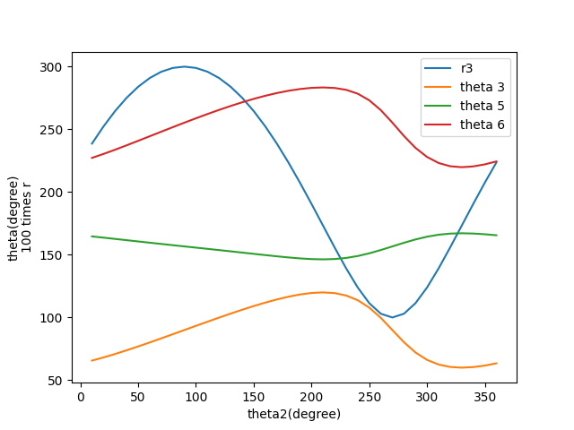

2. Position D and E

(a) w2 = 10, a2 = 0

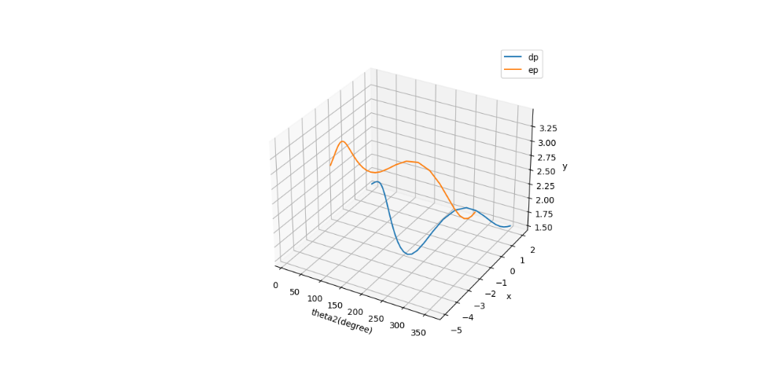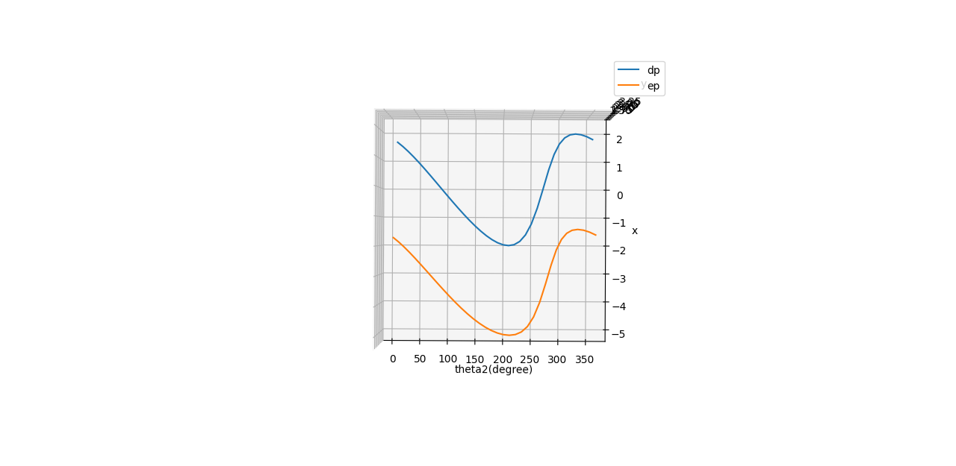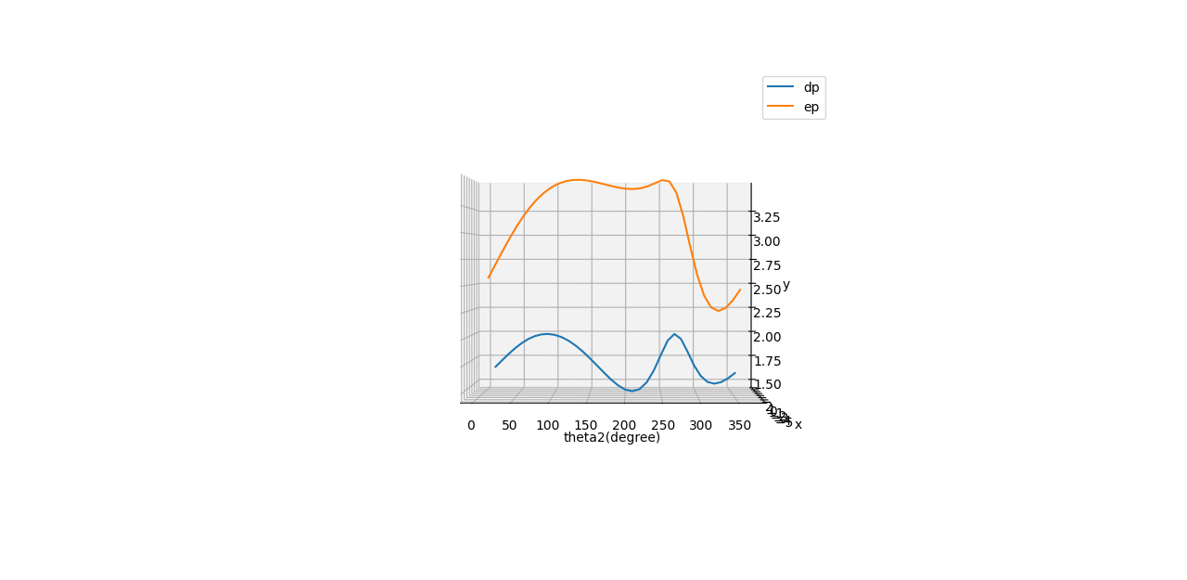

(b) w2 = 0, a2 = 2

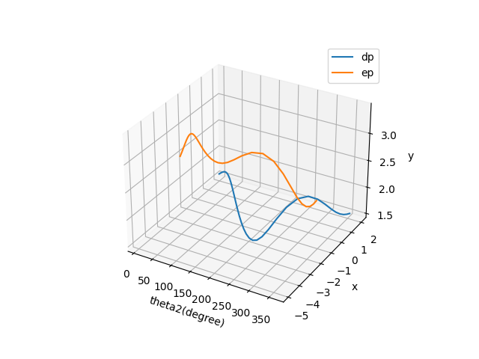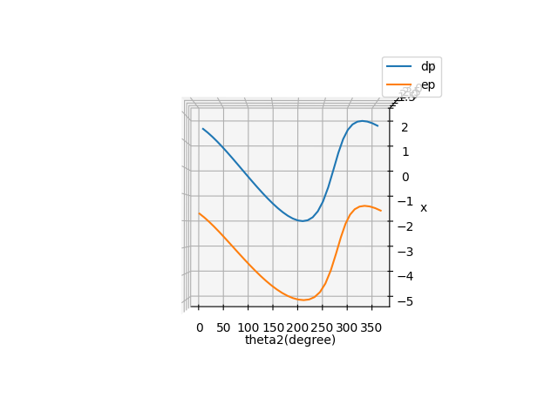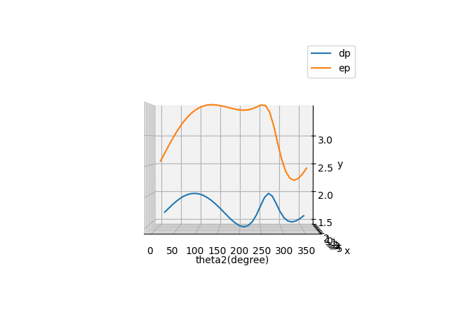

3. velocity plots

(a) w2 = 10, a2 = 0

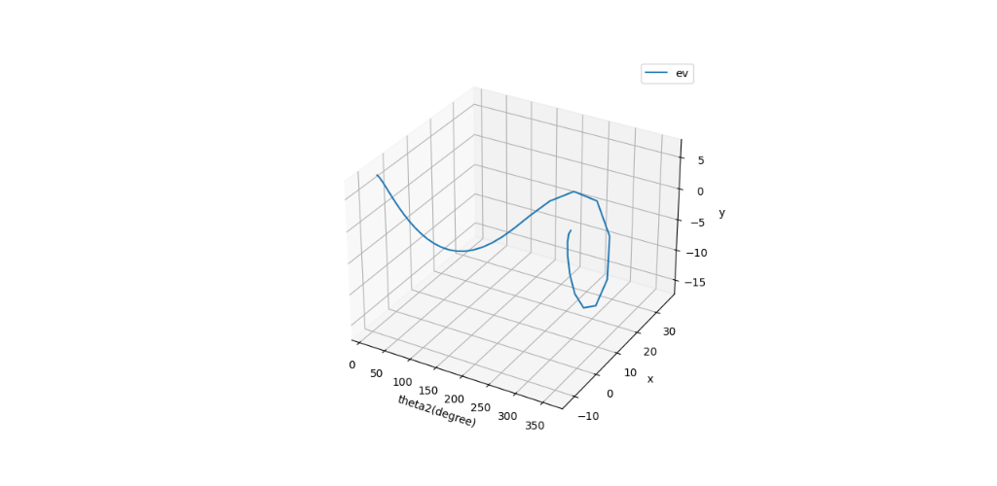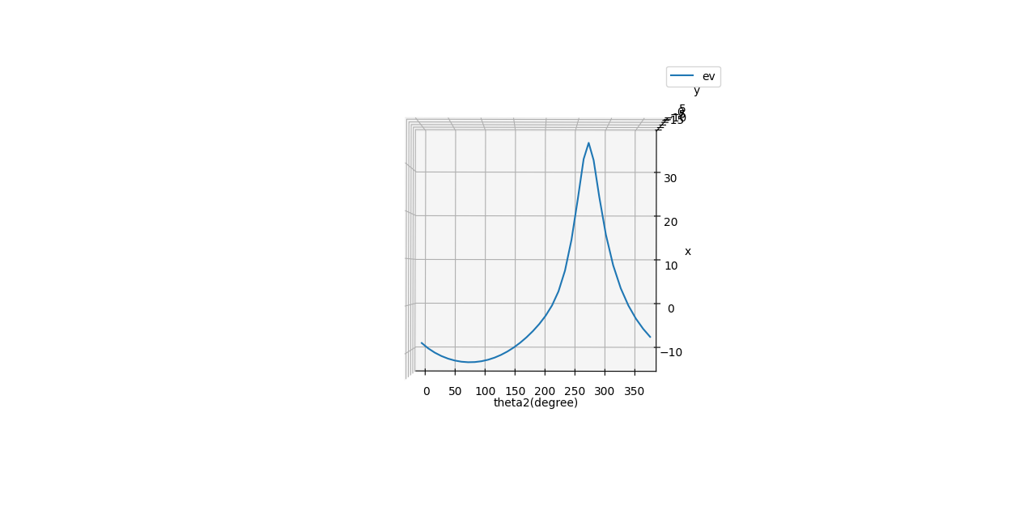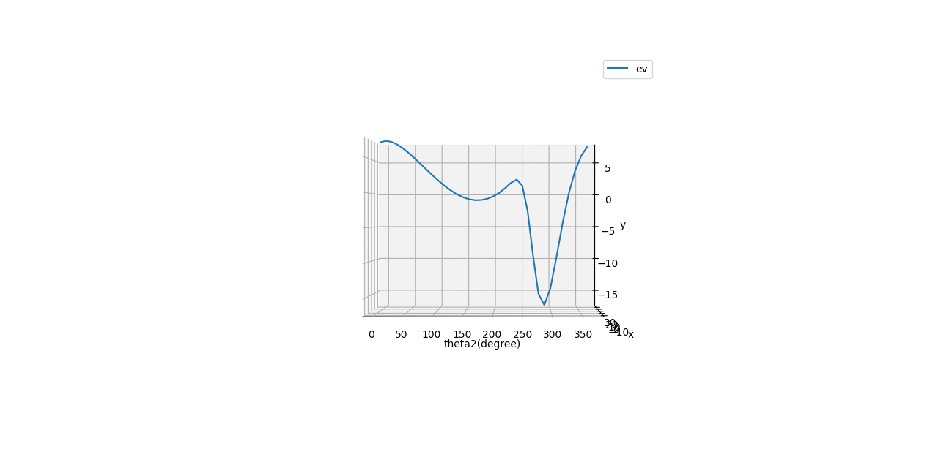

(b) w2 = 0, a2 = 2

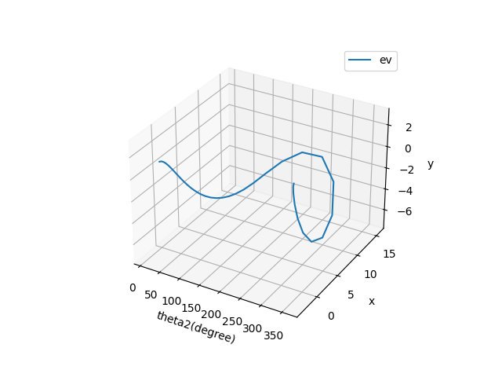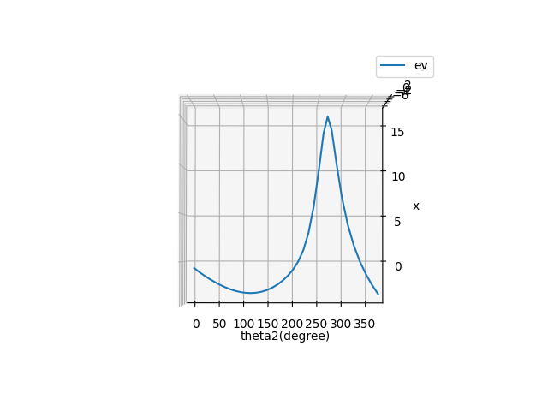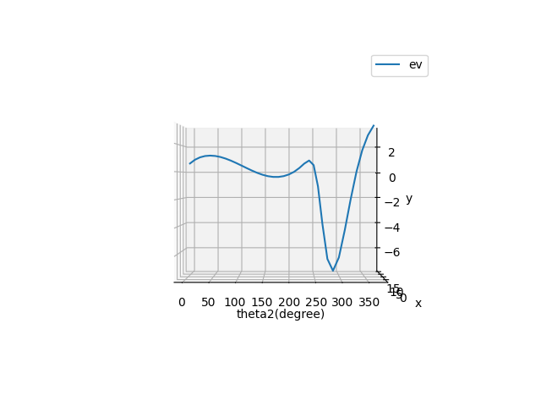

4. acceleration plots

(a) w2 = 10, a2 = 0

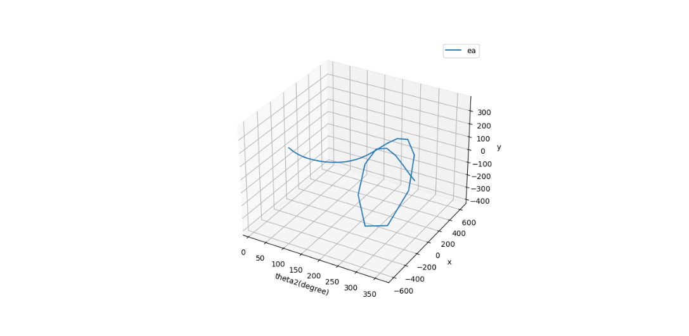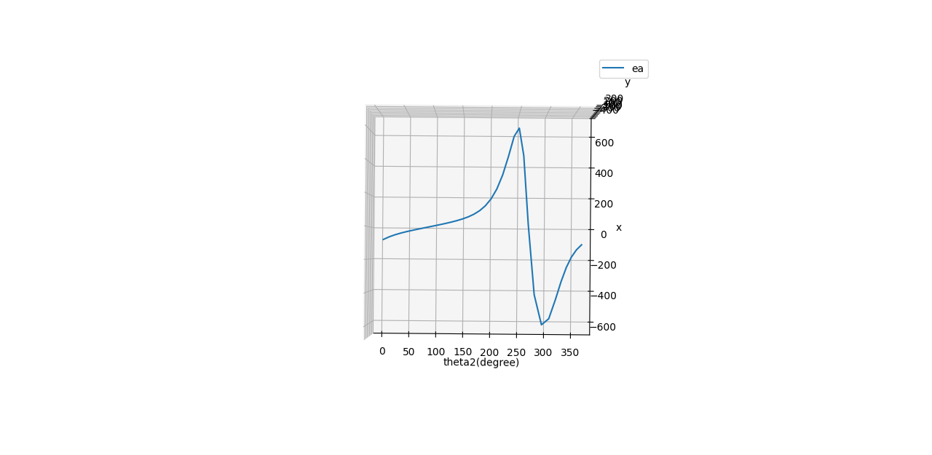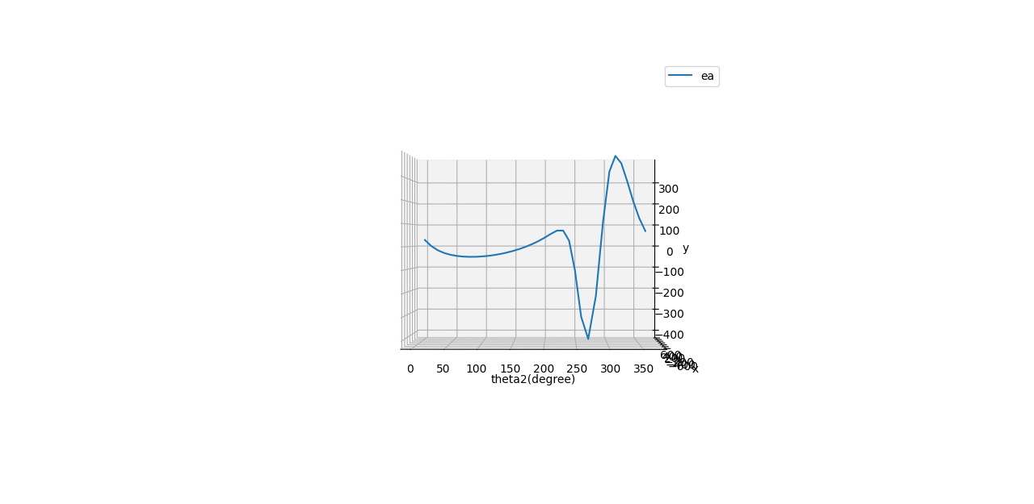

(2) w2 = 0, a2 = 2

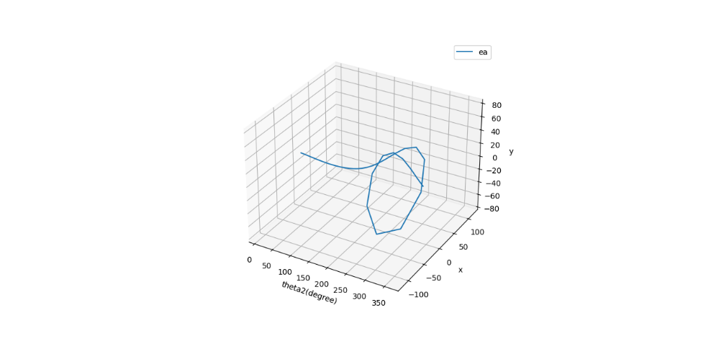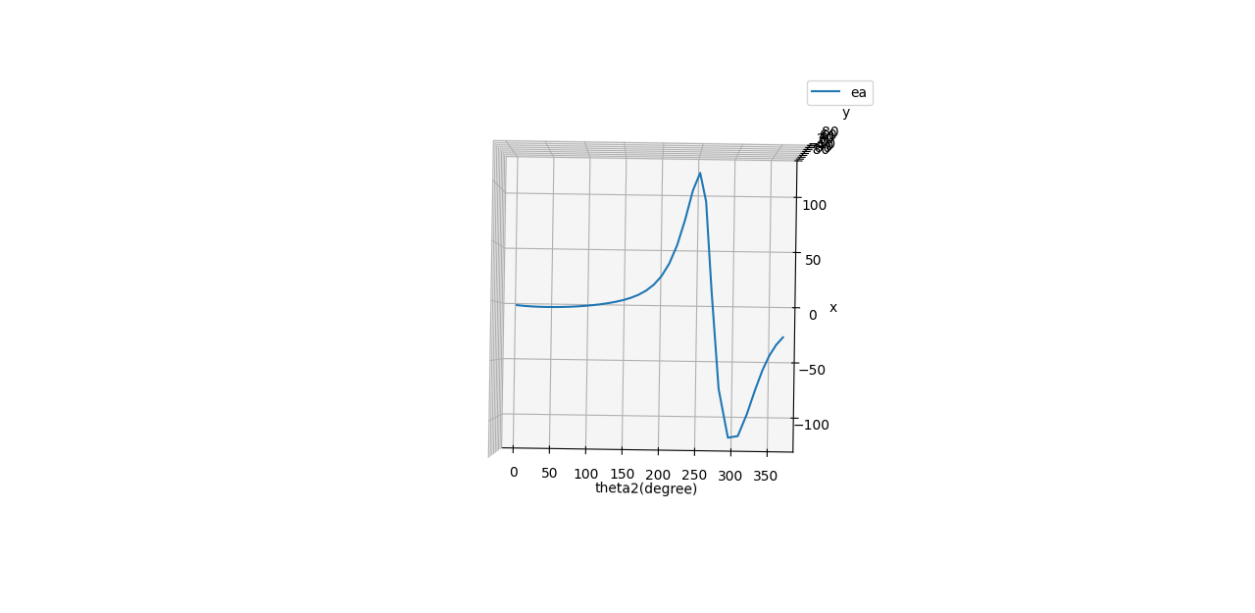 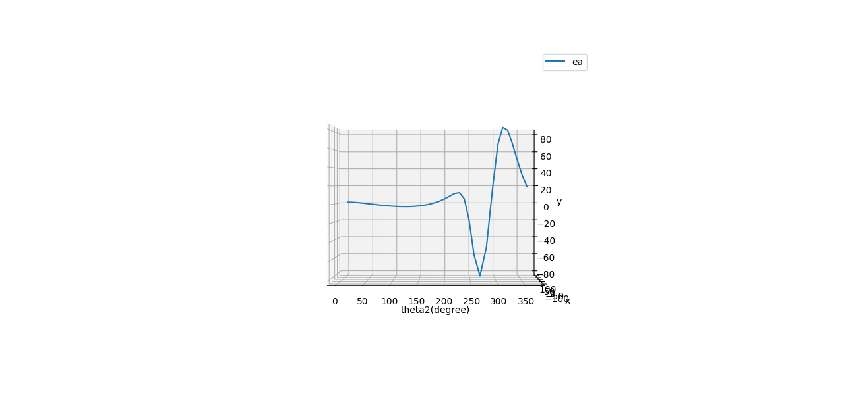 5. Tables

Theta2 is the input angle in degree, Dpx is the position of D in the x direction, v indicates velocity, a represents acceleration, and w6 is the angular velocity of link 6.

(a) w2 = 10, a2 = 0

theta2 Dpx Dpy Epx Epy Evx Evy Eax Eay w6

-------- ------- ------ ------- ------ -------- -------- --------- --------- --------

10 1.6507 1.6435 -1.7244 2.5703 -7.7305 7.1449 -78.0727 29.0471 3.0076

20 1.4895 1.7123 -1.8691 2.6969 -8.8307 7.3046 -61.0041 1.7621 3.2744

30 1.3093 1.7796 -2.0315 2.8233 -9.7387 7.1351 -47.7633 -16.6298 3.4494

40 1.1136 1.8419 -2.2081 2.9446 -10.4788 6.7325 -36.9631 -28.9348 3.5586

50 0.9054 1.8962 -2.3963 3.0574 -11.0651 6.1658 -27.6940 -37.0490 3.6192

60 0.6875 1.9405 -2.5935 3.1592 -11.5055 5.4864 -19.3654 -42.1952 3.6419

70 0.4623 1.9732 -2.7971 3.2485 -11.8039 4.7342 -11.5936 -45.1414 3.6337

80 0.2323 1.9932 -3.0047 3.3242 -11.9624 3.9413 -4.1241 -46.3615 3.5986

90 0.0000 2.0000 -3.2139 3.3860 -11.9812 3.1355 3.2221 -46.1418 3.5385

100 -0.2323 1.9932 -3.4221 3.4337 -11.8598 2.3412 10.5878 -44.6491 3.4539

110 -0.4623 1.9732 -3.6271 3.4679 -11.5969 1.5816 18.1124 -41.9725 3.3441

120 -0.6875 1.9405 -3.8261 3.4893 -11.1908 0.8783 25.9625 -38.1498 3.2072

130 -0.9054 1.8962 -4.0168 3.4990 -10.6389 0.2528 34.3682 -33.1833 3.0406

140 -1.1136 1.8419 -4.1966 3.4987 -9.9387 -0.2745 43.6714 -27.0483 2.8407

150 -1.3093 1.7796 -4.3629 3.4901 -9.0869 -0.6845 54.3952 -19.6959 2.6036

160 -1.4895 1.7123 -4.5129 3.4756 -8.0799 -0.9600 67.3470 -11.0479 2.3248

170 -1.6508 1.6435 -4.6440 3.4575 -6.9125 -1.0876 83.7710 -0.9818 1.9993

180 -1.7889 1.5777 -4.7532 3.4385 -5.5744 -1.0590 105.5715 10.6926 1.6212

190 -1.8985 1.5208 -4.8374 3.4214 -4.0392 -0.8706 135.6193 24.2404 1.1806

200 -1.9723 1.4799 -4.8927 3.4091 -2.2376 -0.5203 178.1233 39.8695 0.6564

210 -2.0000 1.4641 -4.9130 3.4043 0.0000 0.0000 238.9068 57.0560 0.0000

220 -1.9661 1.4834 -4.8881 3.4102 3.0336 0.7010 324.8330 72.2242 -0.8896

230 -1.8480 1.5475 -4.7989 3.4295 7.4844 1.5253 439.5294 72.5636 -2.1824

240 -1.6137 1.6600 -4.6142 3.4620 14.0822 2.0917 566.7430 25.6345 -4.0676

250 -1.2277 1.8069 -4.2940 3.4946 22.8850 1.2705 629.6027 -115.3755 -6.5487

260 -0.6744 1.9427 -3.8146 3.4883 31.7277 -2.5954 470.4578 -328.9906 -9.0953

270 0.0003 2.0000 -3.2136 3.3859 35.9443 -9.4100 28.8683 -415.2913 -10.6159

280 0.6742 1.9428 -2.6055 3.1649 32.6008 -15.3941 -419.2092 -212.7398 -10.3008

290 1.2280 1.8068 -2.1049 2.8757 24.3442 -16.8902 -593.6519 106.5869 -8.4656

300 1.6138 1.6600 -1.7575 2.6005 15.6561 -14.1030 -546.5235 321.5687 -6.0204

310 1.8479 1.5476 -1.5479 2.3952 8.7046 -9.2747 -431.2887 391.9879 -3.6342

320 1.9661 1.4834 -1.4426 2.2777 3.6438 -4.2513 -323.1520 363.2612 -1.5998

330 2.0000 1.4641 -1.4124 2.2421 0.0000 0.0000 -238.9857 286.4679 0.0000

340 1.9723 1.4799 -1.4370 2.2713 -2.6928 3.1572 -177.1524 200.1211 1.1856

350 1.8985 1.5208 -1.5028 2.3462 -4.7578 5.2669 -132.7419 125.4718 2.0279

360 1.7889 1.5777 -1.6007 2.4502 -6.3968 6.5252 -101.0101 68.9594 2.6108

(b) w2 = 0, a2 = 2

theta2 Dpx Dpy Epx Epy Evx Evy Eax Eay w6

-------- ------- ------ ------- ------ ------- ------- --------- -------- -------

10 1.6507 1.6435 -1.7244 2.5703 -0.6459 0.5970 -2.5680 2.0725 0.2513

20 1.4895 1.7123 -1.8691 2.6969 -1.0435 0.8631 -3.1389 1.9165 0.3869

30 1.3093 1.7796 -2.0315 2.8233 -1.4094 1.0326 -3.4981 1.4817 0.4992

40 1.1136 1.8419 -2.2081 2.9446 -1.7511 1.1251 -3.6969 0.9040 0.5947

50 0.9054 1.8962 -2.3963 3.0574 -2.0673 1.1520 -3.7611 0.2639 0.6762

60 0.6875 1.9405 -2.5935 3.1592 -2.3548 1.1229 -3.7022 -0.3888 0.7454

70 0.4623 1.9732 -2.7971 3.2485 -2.6094 1.0466 -3.5241 -1.0199 0.8033

80 0.2323 1.9932 -3.0047 3.3242 -2.8270 0.9314 -3.2258 -1.6024 0.8504

90 0.0000 2.0000 -3.2139 3.3860 -3.0032 0.7859 -2.8035 -2.1125 0.8870

100 -0.2323 1.9932 -3.4221 3.4337 -3.1336 0.6186 -2.2501 -2.5270 0.9126

110 -0.4623 1.9732 -3.6271 3.4679 -3.2137 0.4383 -1.5547 -2.8215 0.9267

120 -0.6875 1.9405 -3.8261 3.4893 -3.2391 0.2542 -0.6991 -2.9704 0.9283

130 -0.9054 1.8962 -4.0168 3.4990 -3.2051 0.0762 0.3455 -2.9457 0.9160

140 -1.1136 1.8419 -4.1966 3.4987 -3.1072 -0.0858 1.6267 -2.7166 0.8881

150 -1.3093 1.7796 -4.3629 3.4901 -2.9406 -0.2215 3.2218 -2.2489 0.8425

160 -1.4895 1.7123 -4.5129 3.4756 -2.7004 -0.3208 5.2568 -1.5033 0.7770

170 -1.6508 1.6435 -4.6440 3.4575 -2.3814 -0.3747 7.9360 -0.4322 0.6888

180 -1.7889 1.5777 -4.7532 3.4385 -1.9761 -0.3754 11.5866 1.0245 0.5747

190 -1.8985 1.5208 -4.8374 3.4214 -1.4711 -0.3171 16.7256 2.9430 0.4300

200 -1.9723 1.4799 -4.8927 3.4091 -0.8361 -0.1944 24.1493 5.3991 0.2453

210 -2.0000 1.4641 -4.9130 3.4043 0.0000 0.0000 35.0256 8.3648 0.0000

220 -1.9661 1.4834 -4.8881 3.4102 1.1889 0.2747 50.8661 11.3182 -0.3486

230 -1.8480 1.5475 -4.7989 3.4295 2.9991 0.6112 72.8746 12.1201 -0.8745

240 -1.6137 1.6600 -4.6142 3.4620 5.7643 0.8562 99.0103 4.8969 -1.6650

250 -1.2277 1.8069 -4.2940 3.4946 9.5607 0.5308 116.0505 -19.7946 -2.7358

260 -0.6744 1.9427 -3.8146 3.4883 13.5174 -1.1058 93.5373 -60.3826 -3.8750

270 0.0003 2.0000 -3.2136 3.3859 15.6056 -4.0855 14.4594 -80.6414 -4.6090

280 0.6742 1.9428 -2.6055 3.1649 14.4137 -6.8062 -73.7557 -45.4530 -4.5542

290 1.2280 1.8068 -2.1049 2.8757 10.9538 -7.5998 -113.9696 17.2638 -3.8091

300 1.6138 1.6600 -1.7575 2.6005 7.1649 -6.4542 -110.3769 63.6679 -2.7552

310 1.8479 1.5476 -1.5479 2.3952 4.0495 -4.3147 -91.0283 82.3714 -1.6907

320 1.9661 1.4834 -1.4426 2.2777 1.7223 -2.0094 -71.2158 80.0134 -0.7561

330 2.0000 1.4641 -1.4124 2.2421 0.0000 0.0000 -55.0583 65.9975 0.0000

340 1.9723 1.4799 -1.4370 2.2713 -1.3119 1.5382 -42.7722 48.3487 0.5776

350 1.8985 1.5208 -1.5028 2.3462 -2.3519 2.6035 -33.7036 32.0629 1.0024

360 1.7889 1.5777 -1.6007 2.4502 -3.2069 3.2712 -27.0775 19.0562 1.3088

**Discussion**

From the position figure, we can see in the span of 360 input degree all variables begin and ends in the same value, which is expected. In the first set of input parameters, since the angular velocity of the input link is zero, the motion should be continuous. This is shown in the velocity and acceleration curves of the point E: the starting and ending points of the curve is of the same value; whereas in the second set of parameters, the two points of both curves do not have the same values. In the velocity figures, the cyclic phenomenon is absent in the non-zero acceleration condition. As the angular velocity won’t be the same after one revolution, the velocity of the points D and E will be a function of the input angular velocity. It is the same for the acceleration plots.

The curve of angles t3 and t6 are steeper in the right side of the figure. These two links both have one end anchored to the ground link. Combine with the steeper curve in the D & E position plot, and higher velocity of the latter half rotation, this means this is a quick return mechanism. The velocity in both x and y direction peaked around 270 degree, while the velocity in x is in the positive direction and negative in y.

The derivative relations of the position, velocity, acceleration curves are also evident.

**Bonus**

1. The range of input link motion

Whether the input link could perform a whole rotation depends on the link geometries. Basically, the problem is that the links in Loop 2 could pose a constraint on the range of motion of link 3. If the range of motion of link 3 is limited, then it would not allow link 2 to have a full rotation.

We can find the range which link 3 “want”, which is the minimum range for full rotation of link 2:

and

The limitations given by Loop 2:

If and , then link 2 will have a full rotation. This condition is implemented in the code.

The above is a fool-proved way to find which input angles are possible given the parameters. But what about some examples? We can vary the length of r5 and r6 to yield three conditions that the input link in the mechanism cannot fully rotate.

Condition 1: When the parameters rv2, rv1, rv4, rv5, rv6, rv7 equal to 1, 2, 4, 1.5, 1.5, 4.1 respectively, . This means the input link will be constrained so that r2 cannot be perpendicular to r3 in the right side (which is a necessary condition for a full rotation).

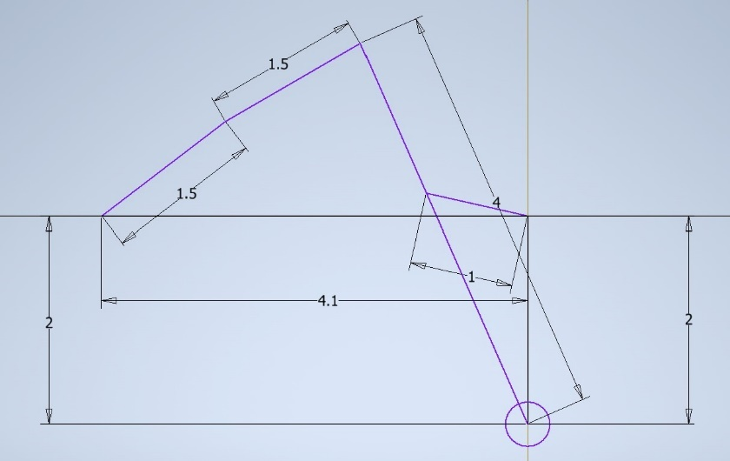

Figure 2

Condition 2: When the parameters rv2, rv1, rv4, rv5, rv6, rv7 equal to 1, 2, 4, 4.5, 7.5, 4.1 respectively, . This means the input link will be constrained so that r2 cannot be perpendicular to r3 in the left side (which is a necessary condition for a full rotation). The possible motion of this mechanism is thus separated into to two ranges.

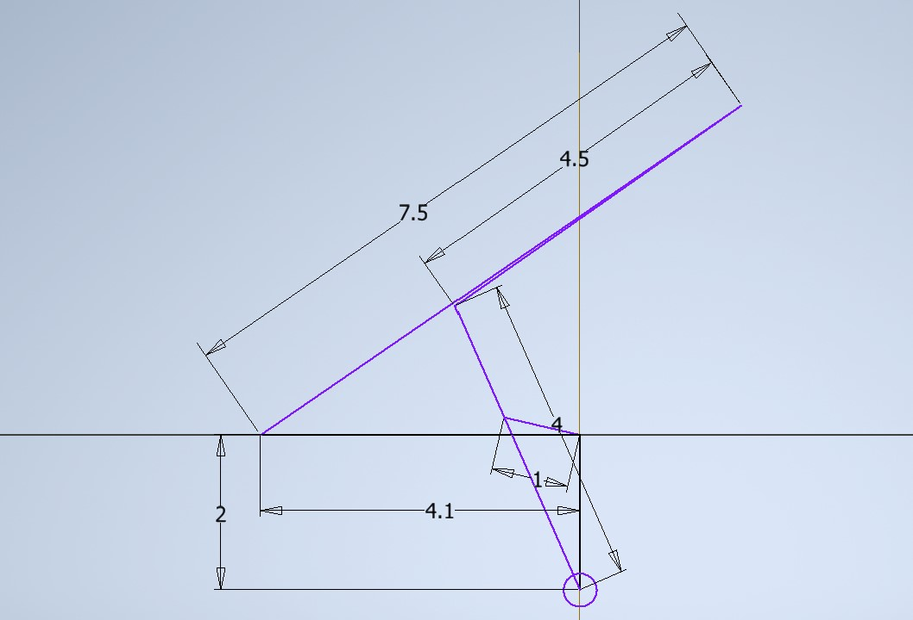

Figure 3

Condition 3: When the parameters rv2, rv1, rv4, rv5, rv6, rv7 equal to 1, 2, 4, 1.5, 4.5, 4.1 respectively, . This means the input link will be constrained so that r2 cannot be perpendicular to r3 in both right and right sides (which is a necessary condition for a full rotation). The possible motion of this mechanism is thus separated into to two ranges.

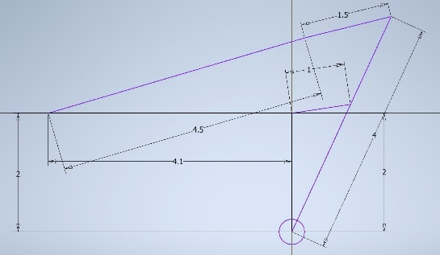 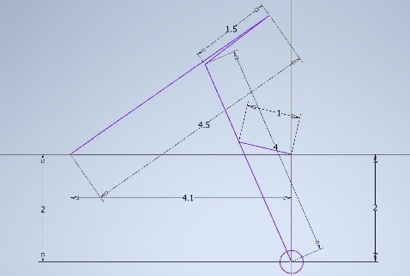

Figure 4, 5

From these examples we can get a feeling of what kinds of length of r5 and r6 will result in which kind of conditions that may be prohibit the input link to rotate: if the summation of the length of r5 and r6 is too small, condition 1 will occur; when the difference of the length r5 and r6 is too large, then will lead to condition 2; if both, will result in condition 3. These findings are also consistent with what the constraint equations suggest.

Note that which condition will happen does not wholly depend on the length of r5 and r6, as seen in the equations. Easier method to discriminate without much calculation is left for readers to derive.

2. A note on initial values using Newton’s method

Newton’s method, also called Newton–Raphson method, is a root-finding algorithm used in numerical analysis. The basic form is the following:

The rationale is using the first order Taylor’s expansion to get a better estimation of the root of the function, until the criterion is meet.

There are several types of problems that may appear to obstruct the convergence of the calculation [1]. Including the derivative of the function cannot be found, the function is complex, the initial guess is not local enough to the true root, cyclic calculation that cannot converge due to the nature of the function, and so on.

The problems I encountered in this linkage analysis is that the wrong roots being yielded. I set the all the initial values to 1.0 at first, including r3, t3, t5, and t6. The calculation in Loop 1 worked out as a dream, but not the same for the calculation in Loop 2. This may due to the fact that it is lucky that the geometry is happen to be close to the guesses, and that the angle of input link and the position of r3 has a one-to-one relation, which provide only one possible root.

The case with t5 and t6 are the opposite. r5 and r6 can almost always have two configurations, one peaks upward and one downward. So the issue is how to find the one that peaks upward?

The first method I tried is to set the values of t5 and t6 in 90 degrees increment. Varying both in 360 degrees. The result is a disaster, multiple roots are found according to the algorithm, while the accuracy is very low. This is clearly not a good way to set the initial values, let alone the efficiency of this algorithm.

The second and the last method I used is to perform a calculation for the geometry when the input link is at 0 degree. First find the angles in triangle DEF when input link is at zero degree. There are two triangles, to solve the problem, I intentionally choose the upper one. Calibrate the result by angle DFA, a precise angle of r5 and r6 is yielded. However, some parameters do not allow the mechanism to exist if the input link is at 0 degree. In these instances, set the initial values of r5 and r6 close to the results calculated when r5 and r6 is in a sequential line (as shown in figure 2), and set t6 to be larger than r6 to ensure it peaks upward in the following iteration. This way we can ensure the configuration is always the desired one.

Good initial guess is crucial when using Newton’s method. Even when the problem is more difficult that the precise initial values cannot be attained, using maximum likelihood is a must to have good initial values.

**Reference**

[1] (2022). Retrieved 22 November 2022, from http://www.cas.mcmaster.ca/~cs4te3/notes/newtons_method.pdf